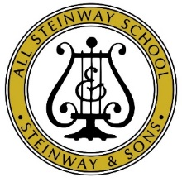
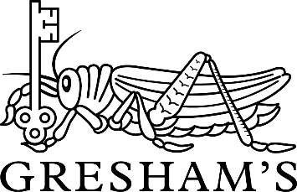

Pre-Prep Music Lessons
Terms and Conditions

- The first term of lessons are considered ‘trial’ lessons and, should your child decide to stop lessons during this period, you will only need to pay for that first term. After this period, written notice to terminate lessons must be given half a term in advance. Please email from Fiona Ross, Music Administrator: fross@greshams.com before the first day of a Term to take effect at the start of the second half of Term, or before the start of a Half-Term holiday to take effect at the end of that term.

- Weekly lessons will be arranged between the music teacher and the child’s class teacher. If a teacher is absent no charge is made for the lesson, unless the teacher concerned is able to make up for it elsewhere. No credit is allowed for lessons missed by pupils, unless by special arrangement with the Director of Music.

- Instruments can be hired from School, or hired or bought from local music shops. If a child owns their own instrument, it should be CLEARLY MARKED and the make, model and serial number should be kept by the parents.

- Insurance: school instruments are covered by the School’s policy, whilst kept in the UK. If instruments are to be taken overseas, responsibility rests with the parents. As pupil’s own instruments are NOT covered by school insurance, we do urge you to make sure that any instrument is adequately insured.

- The music staff welcome any chance to talk to parents. Comments on progress, the pupil’s relationship with the teacher, thoughts about practice and repertoire are all very valuable. Please ensure that all communication to music staff is directed through the Director of Music or Music Administrator unless it is simply regarding a change of lesson time.

May 2019

